A friend of mine has a pair of Commando 850 MkIII’s, both fitted with LED lights throughout, including side lights and instrument lights.
He was in the garage one day when he turned the ignition to ON and then pressed the brakes, he was surprised when he saw the front light go on, remember this is a LED sidelight so is very bright and is even ok to use as daytime riding lights.
You could say ‘so what?’, but imagine the situation when you are driving along and every time you apply the brakes, the ‘headlight’ will come on. What are other road users going to think? You are flashing to let them pull out?
His initial thought was a wiring issue of some sort, so he then tried the same test on the other MkIII with the same results.
He also noticed that if you turned the switch to ‘park’ then applying the brakes made the side lights go out. Not an issue but an indication of something strange going on.
So, he talked to me, and I put some thought into it, I suggested he puts a standard stop / tail light in and as expected, everything worked as it should so it was obviously something related to the LED stop / tail light.
He brought one of the bulbs round to me and I tried it in my Commando, it had the same situation with the switch in ‘park’ and applying the brakes but did not put the front sidelight on when the ignition was on and the brakes were applied, but I do not have an LED sidelight. This gave me an indication of what the problem was. I removed the bulb from my sidelight and measured 10V when the brake was applied.
I then went back to the stop/tail light and investigated the way it works. As LED’s are much more directional than filament bulbs, it has one LED pointing downwards to light the number plate and a handful around the edge to be both the tail light and stop light.
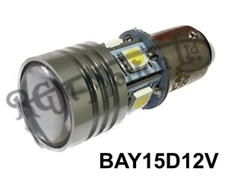
The way the ones around the side change from the equivalent of a 21W (Brake) to a 5W (Side) is there is an 86 ohm resistor in series. This acts as a current limiter.

First a reminder of how the standard wiring and bulb works.
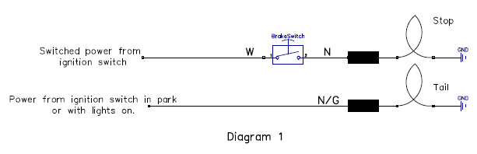
Now this is how it looks with the LED bulb fitted.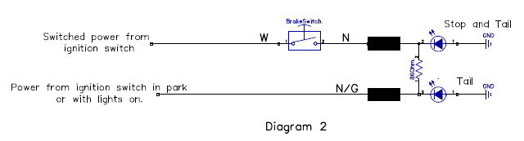
The 86 ohm resistor is internally fitted between the ‘N’ from the brake light supply line and the ‘NG’ from the tail light supply.
If the ignition is ON, then there is power on the ‘W’ wire (this is switched volts from the ignition switch). Then pressing the brake switch (either front or rear) will put volts directly on the stop light and also via the 86 ohm resistor on the tail light, This in itself is not a problem but the ‘NG’ wire also connects to the instrument lights and front sidelight. These will all come on as they are very low current. Note if you have a normal filament sidelight bulb will not have the same problem as the current supplied through the 86 ohm resistor will be insufficient to light the bulb up.
A simple solution to this would be to fit a pair of diodes, one in the ‘NG’ line to prevent the feedback from the brake light powering the NG line. And one in the N line to prevent the brake switch turning the parking light off when in park. See diagram below.
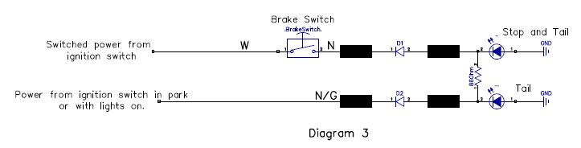
Suggest a 3A diode such as 1N5404 so will still work if a standard bulb is refitted.

Pack of 4 from Tandyonline.com about £2.50 including postage.
This is how I have done it. Mainly shown so you can see which way round the diodes go.
