Rear Dampers
The Norton Dominator Plunger (or Spring Frame) relied on two sets of springs, either side of the rear wheel, to control the back end of the bike. The set-up worked reasonably well if frequently serviced and the machine never ridden fast. However, if not kept in good condition individual components would either wear very quickly or seize solid. The problem with serving Plunger rear suspension units is the difficulty in removing them from the frame safely.
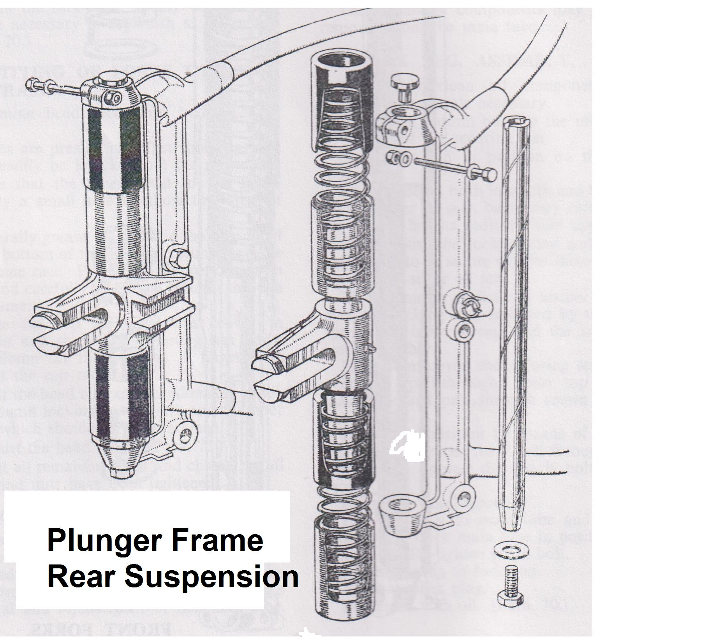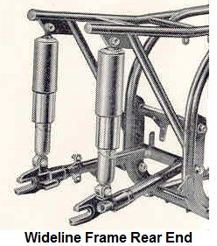

From 1952 up to 1957 Armstrong units, were fitted to the Model 7 and Wideline Frames. The first of these units had no means of adjustment to cope with a passenger load but later versions came with an adjustment ring to alter the spring preload. Then Girling oil damped 3-position units arrived to become the standard fitment. Eventually, as with many other motorcycle component suppliers, the demise of most British manufacturers led to Girlings association with Norton motorcycles ending. However, a number of specialist companies now produce variations of the Girling type and some specialise in refurbishing the older suspension units. This service does tend to cost much more than purchasing new reproduction parts.
The Girling Wideline suspension units were on the scene for about 4 years, until the Slimline frame arrived in 1960. These units had an extended length of 12.9 “and came with 80 lb springs. 110 lbs spring (145 lb sidecar). These dimensions being similar to the earlier Armstrong units.
A rubber bush in an eye assembly was welded to both the top and bottom with bushes for 5/16 bolts. These units had a reputation for quickly going soft both in terms of damping, and the springs. Many owners changed the springs for beefier 126 lb items and generally reported batter handling as a consequent. For those of us who find dieting a serious challenge then up rating the springs is probably a sensible move anyway.
The Slimline Frame 1960-69 had shorter suspension units, on all models, with an extended length of 11.9”. Again, the springs were 110 lbs (145 lbs combo). The top bush was 5/16”.
The Commando rear units reverted to the 12.9 extended length with a spring of 126 lbs but this time the bushes are the same at 3/8 top and bottom but bush lengths are shorter. Therefore, buy a bush change and/or drilling the frame and swinging arm Commando units maybe-even with 126 lbs springs (early Commando standard) can be fitted to the Wideline (later Commando springs were 150 lbs.)

Spring colours: Except on Chromed, replacement springs the springs were painted Black. The two outer colours are the same and are the 'primary' colour, the middle being the 'secondary' colour. The 110 lbs on the Slimline being red/red free length being Wideline/Commando 8.4 in.
By the mid1970s, manufacture of the standard oil-filled units by Girling had ceased. A new range of gas shocks then became available from this company. From then on replacement standard and sports rear suspension units were provided by specialist companies such as Hagon Shocks.
For all Slimline frame models except combinations, replacement gas shocks were listed as:
Series A no. 6237 extended centre to centre of 11.9 in (302mm). Compressed centres 8.7 in (223mm). Bush T/64533656. Bush B 64533651, Spring p/n 9054-277 - 110 lbs.
Shock absorber only: p/n 6069. 88 and 99 combination: p/n 6335. Centres and Bushes as above. Spring: p/n 64543318 -145 lbs. shock absorber only: p/n 6079.
All rear dampers, as fitted to featherbed frames, were finished with a painted top cover of either black or dove grey, (early two tone Slimline), while the bottom spring cover was always chrome.
Replacement dampers often came with mounting kits to fit a range of Norton models and bikes from other manufacturers. The following data refers to distances between the two centres of each damper mounting point.

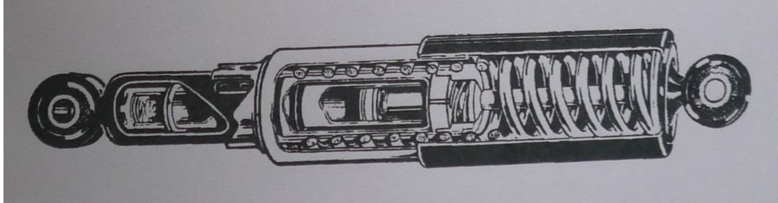

 | Length overall | Top bolts | Bottom bolts
Model 7 | 12.90” | 5/16” | 5/16”
Manx (1956 on) | 13.375” | 5/16” | 5/16”
Wideline | 12.90” | 5/16” | 5/16”
Slimline | 11.87” | 3/8” | 5/16”
Commando | 12.90” | 3/8” | 3/8”

When purchasing replacement rear units ensure that you are getting the correct set for your model. Check the length of the unit and its spring rating. The range here is from 85lb for Wideline frames up to 150lb on some Commando bikes. Also make certain that the top and bottom-mounting bushes are the correct sizes for your frame or there alternates available.

Norton 500cc and 600cc Nomad scrambler models, from 1958 to 1960.
Nomad - Girling Rear Suspension Unit
Part / Number: 3875 (SB4)
Damper only: p/n 3888
Unit length extended: 12.90 inches
Unit length compressed: 10.40 inches Spring: p/n 9054/70
Colour code: Primary red:
Secondary blue
Spring rate: 110lbs
Spring length: 8.40 inches
Outer shield: p/n 64533025A
Normal fitted pre-load: 45 lbs
Top shield length: 5”, painted black
Lower Shield: Chrome plated
Spring retainers: p/n 9054/171
Bottom fixing bolt: p/n 18704
Length: 5/16 x 26 x 1.343 inches
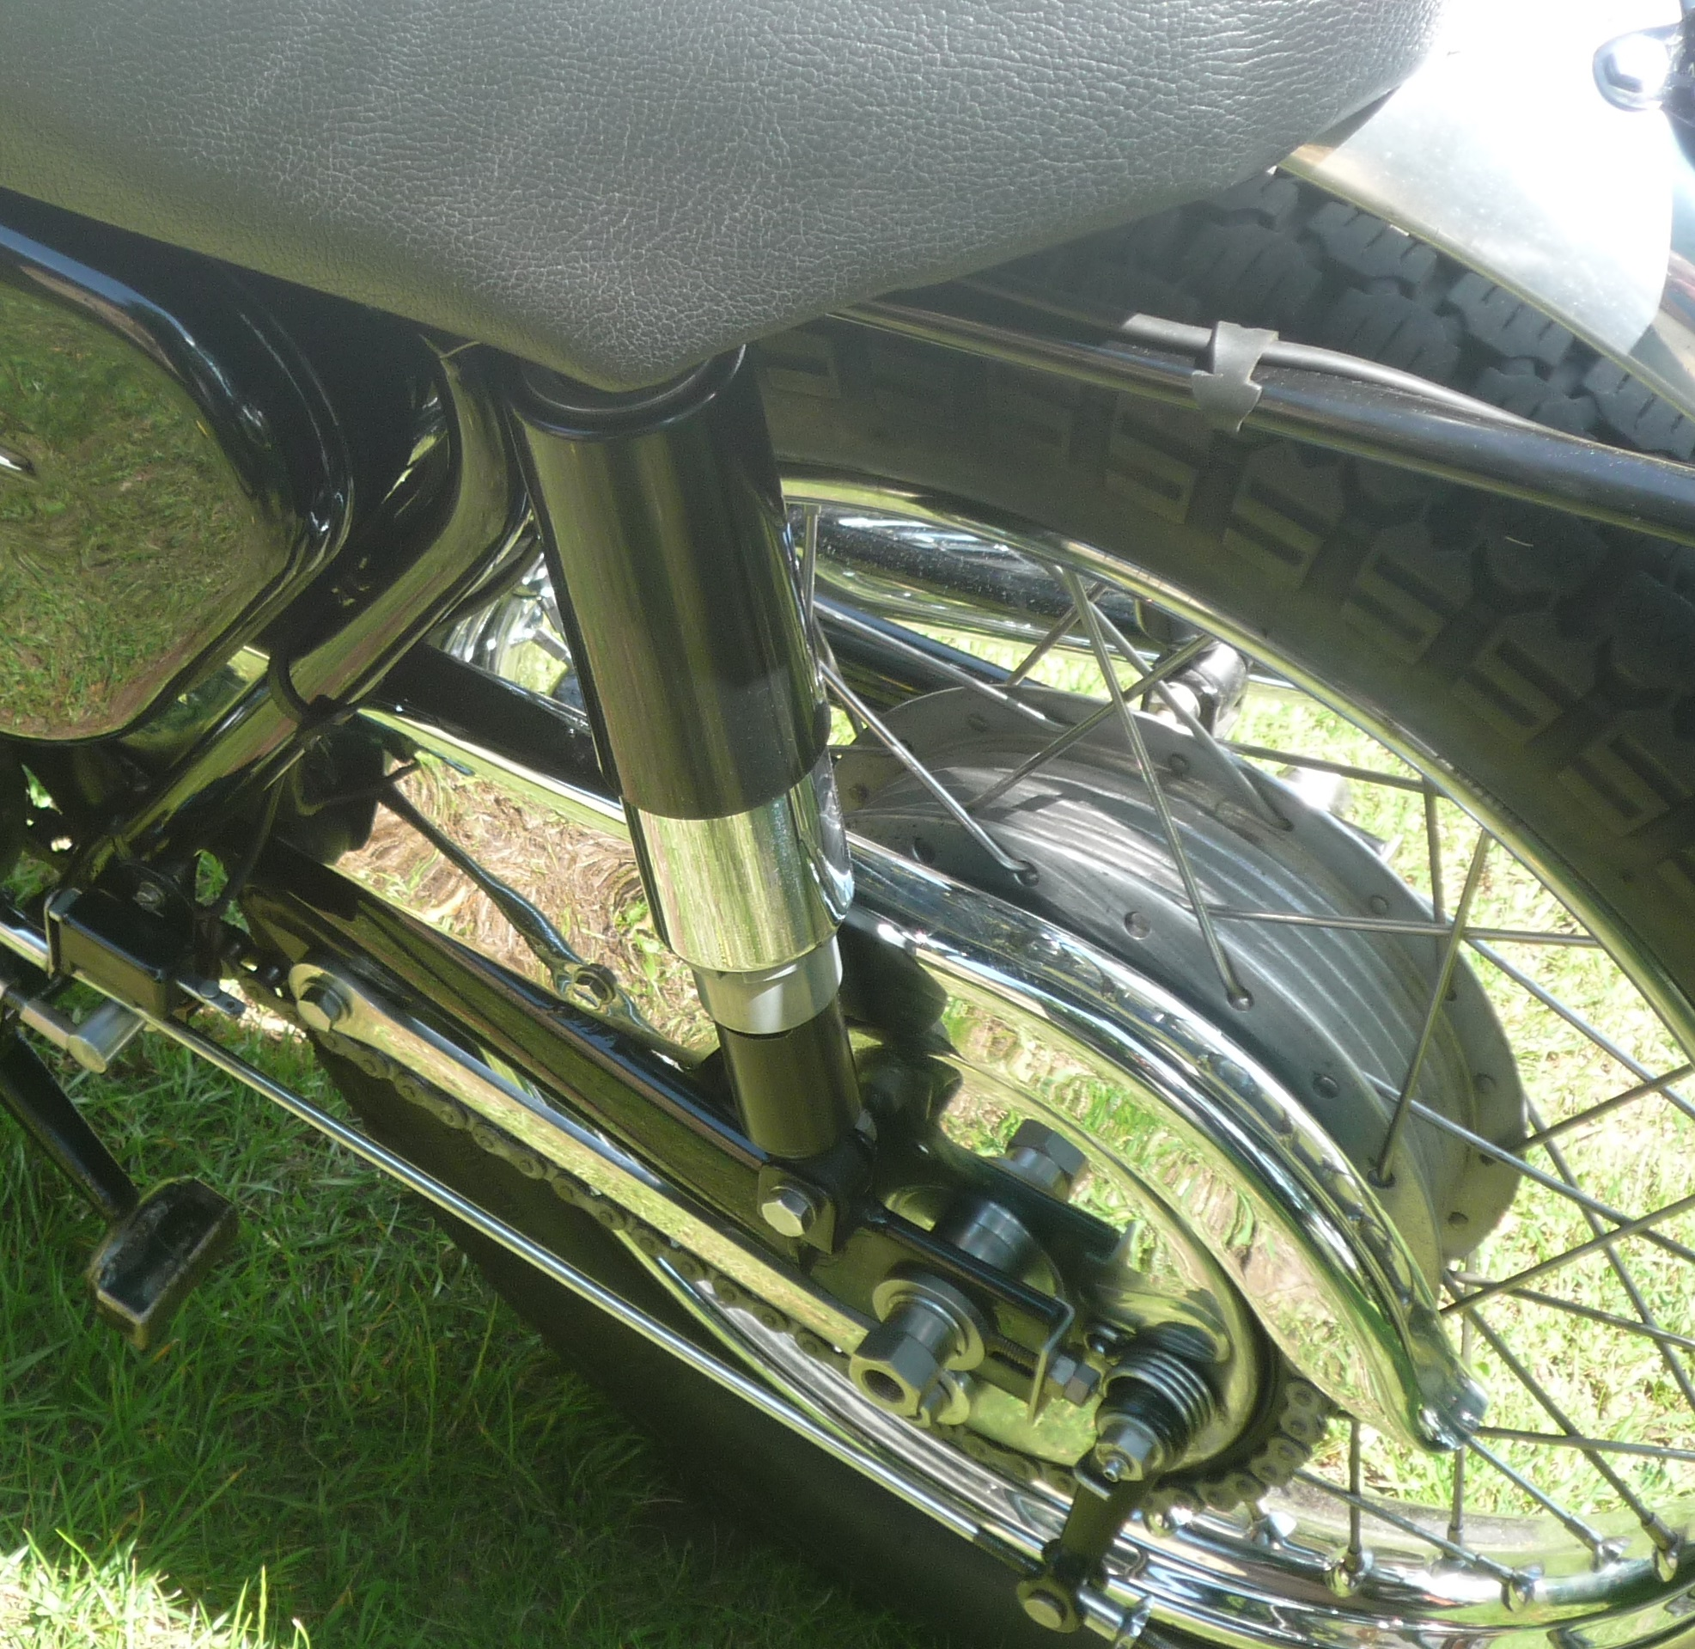

The Nomad swinging arms were different to those on the road models. So washers used on the P11, N15CS, G15CS and the other later Hybrid models can not be used on them. All Hybrid 750 models damper units were painted black and had Chrome lower shrouds when they left the Girling factory.

Girling rear units fitted as standard to the Hybrid 750 models

P11 series of models, from 1967 to 1968. Norton Atlas Scrambler - 1963, N15CS - 1964 to 1968
Complete shock absorber 4590 (SB4)
Shock absorber only: p/n 4592
Unit length: extended 13.40 inches - Compressed 10.30 inches.
Ferrule tube, with bush, assembly: p/n 64533645
Tube length: 0.942 inches
Bolt diameter: 0.375 inches
Spring: p/n 9054/94,
Colour code: green/white
Free length: 9.70 inches. Minimum working length 4.50 inches, spring code 90GW94
Rate: 90lbs/inches
Length: 9.40 inches
Normal fitted pre-load: 27lbs.
Upper dirt shield - painted black, part number 64532961A
Length: 6 inches
Girling spring retainers, standard type 9054/171

IMPORTANT: Warning - Please take note of below as this could save your life. This applies to all the Hybrid 750 models.

Special Fittings:
Rear suspension bottom bolts; p/n 029627 - 3/8” x 26tpi x 1.875”
Bottom bolt washer: p/n 000010 under the bolt head, 3/8” x ¾ x 2mm
Bottom bolt washers: p/n 22636 - 3/8” x 1 x 3/32
Bottom bolt nuts: p/n V000003 3/8” x 26 tpi.

These models are fitted with a very specific lower suspension assembly. The bolt head and washer p/n 000010 should be inside the swinging arm assembly and the nut and its special washer should be on the out side. This lower assembly is for all of the hybrid 750 models that were produced with Norton, Matchless, and AJS petrol tank badges. This arrangement makes changing the rear suspension units easier and crucially the whole fitting safer. A very specific washer is used under the nut p/n 000003. If this is not fitted then, the bush assembly can come away or pull out from the lower shock absorber units housing, possibly causing a rider to lose control of the bike.

Matchless G15CSR, G15Mk2, AJS 33CSR, AJS 33Mk2 or 33Std - 1964 to 1968
Complete suspension unit: p/n 4763(SB4)
Shock absorber unit only: p/n 4764
Length extended: 12.90 inches
Length compressed: 9.90 inches
Ferrule tube, with bonded bush assembly: p/n 64533645
Ferrule Tube length size: 0.942 inches. Tube diameter: 0.375 inches
Spring: p/n 64543114
Spring rate: 110lbs
Spring length free: 8.4 inches
Normal fitted pre-load: 45lbs
Outer shield: 5 inches long. p/n 64533024A, was painted black
Spring retainers, standard type 9054/171
The G15CSR and AJS 33CSR model rear suspension units used chromed outer springs and had chromed top spring covers.

